**Coding Examples**

**1. Basic Integration Example**

# Define the function to integrate

f <- function(x) { x^2 }

# Perform integration

result <- integrate(f, lower = 0, upper = 1)

# Print result

print(result$value)

output:

> f <- function(x) {x^2}

> result <- integrate(f,lower=0,upper=1)

> print(result$value)

[1] 0.3333333

**2. Advanced Integration Example Using pracma**

library(pracma)

# Define the function to integrate

f <- function(x) { sin(x) }

# Perform integration

result <- integral(f, lower = 0, upper = pi)

# Print result

print(result)

output:

f<-function(x) {sin(x)}

> r<-integrate(f,lower=0,upper=pi)

> print(r)

2 with absolute error < 2.2e-14

**3. Visualizing the Integration Result**

library(ggplot2)

# Define the function and create a sequence of x values

f <- function(x) { sin(x) }

x_values <- seq(0, pi, by = 0.01)

y_values <- f(x_values)

# Create a data frame

data <- data.frame(x = x_values, y = y_values)

# Plot the area under the curve

ggplot(data, aes(x = x, y = y)) +

geom_area(fill = "skyblue") +

ggtitle("Area under the curve of sin(x) from 0 to π")

output:

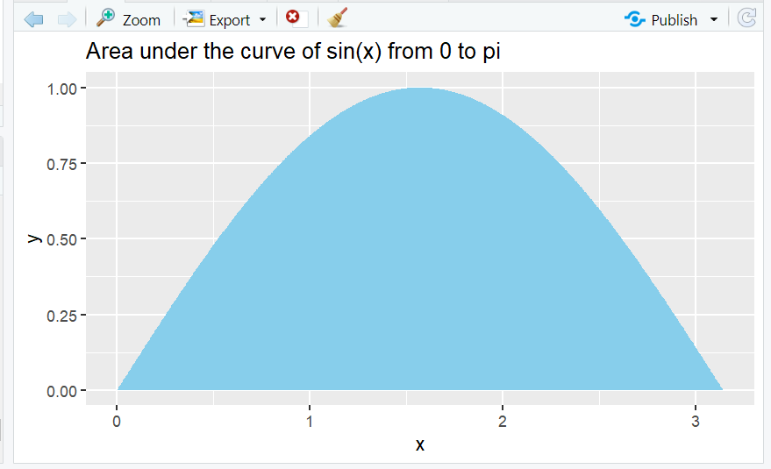

**Exercises**

**1. Exercise 1: Integrate a Polynomial Function**

o Task: Integrate the function f(x)=3x3+2x2+x+1f(x) = 3x^3 + 2x^2 + x +

1f(x)=3x3+2x2+x+1 from 0 to 2.

o Visualize: Plot the function and the area under the curve.

o Expected Output:

# Define the function

f <- function(x) { 3*x^3 + 2*x^2 + x + 1 }

# Perform integration

result <- integrate(f, lower = 0, upper = 2)

print(result$value)

# Visualization

x_values <- seq(0, 2, by = 0.01)

y_values <- f(x_values)

data <- data.frame(x = x_values, y = y_values)

ggplot(data, aes(x = x, y = y)) +

geom_area(fill = "lightblue") +

ggtitle("Area under the curve of 3x^3 + 2x^2 + x + 1 from 0 to 2")

Result

[1] 21.33333

Output:

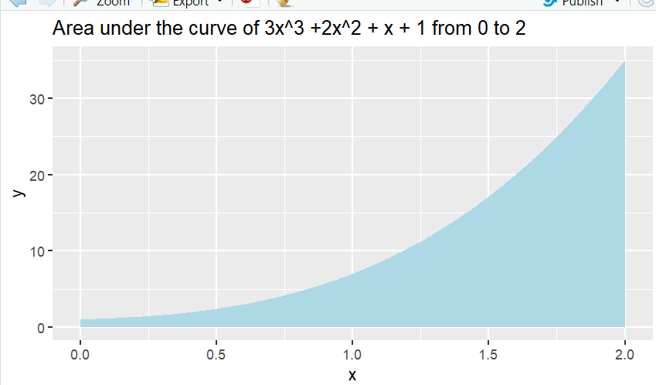

**2. Exercise 2: Integration of Exponential Function**

o Task: Integrate the function f(x)=exf(x) = e^xf(x)=ex from 1 to 3.

o Compare: Compare the result with the analytical solution.

o Expected Output:

# Define the function

f <- function(x) { exp(x) }

# Perform integration

result <- integrate(f, lower = 1, upper = 3)

print(result$value)

# Analytical solution

analytical_result <- exp(3) - exp(1)

print(analytical_result)

# Comparison

cat("Numerical result:", result$value, "\n")

cat("Analytical result:", analytical_result, "\n")

output:

> f<-function(x) {exp(x)}

> result <- integrate(f,lower=1,upper=3)

> print(result$value)

[1] 17.36726

> analytical_result<-exp(3)-exp(1)

> print(analytical_result)

[1] 17.36726

> cat("Numerical result:",result$value,"\n")

Numerical result: 17.36726

> cat("Analytical result:",analytical_result,"\n")

Analytical result: 17.36726

**3. Exercise 3: Double Integration**

o Task: Perform double integration of the function f(x,y)=xy over the region [0, 1]

Expected Output:

# Define the function

f <- function(x, y) { x * y }

# Perform double integration

double_integral <- function(x) {

sapply(x, function(x) integrate(f, lower = 0, upper = 1, y = x)$value)

}

result <- integrate(double_integral, lower = 0, upper = 1)

print(result$value)

output:

f<-function(x,y){x*y}

> double_intergal<- function(x)

+ {

+ sapply(x,function(x) integrate(f,lower=0,upper=1,y=x)$value)

+ }

> result<-integrate(double_intergal,lower=0,upper=1)

> print(result$value)

[1] 0.25

**4. Exercise 4: Integration with Real Data**

o Task: Load a dataset containing time and velocity of a moving object. Compute

the distance traveled by integrating the velocity over time. Visualize the velocity

and the distance traveled.

o Expected Output:

# Example dataset

time <- seq(0, 10, by = 0.1)

velocity <- 3 * time^2 - 2 * time + 1 # Example velocity function

# Create a data frame

data <- data.frame(time = time, velocity = velocity)

# Compute distance traveled using integration

distance_function <- function(t) { 3 * t^2 - 2 * t + 1 }

result <- integrate(distance_function, lower = 0, upper = 10)

print(result$value)

# Cumulative distance

cumulative_distance <- cumsum(velocity) * 0.1

# Visualization

data$cumulative_distance <- cumulative_distance

ggplot(data, aes(x = time)) +

geom_line(aes(y = velocity), color = "blue") +

geom_line(aes(y = cumulative_distance), color = "red") +

ggtitle("Velocity (blue) and Cumulative Distance (red) over Time")

output:

